1) Configure VPC peering in cross regions.

2) Purchase one domain from godaddy.

3) Deploy static webiste in s3.

4) Create CDN and attach one SSL certificate.

5) Create Route53 hosted zone and MAP the domain with CDN.

6) Update the index.html in s3 bucket and the updated file should be accessible by using domain name.

7) Share the Domain name in slack to test the connetivity.

**1) Configure VPC peering in cross regions.**

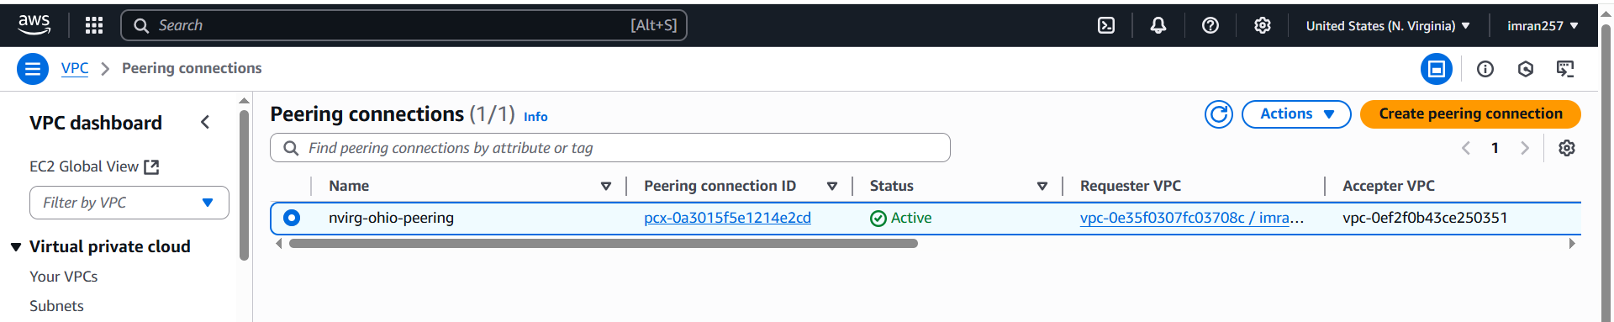

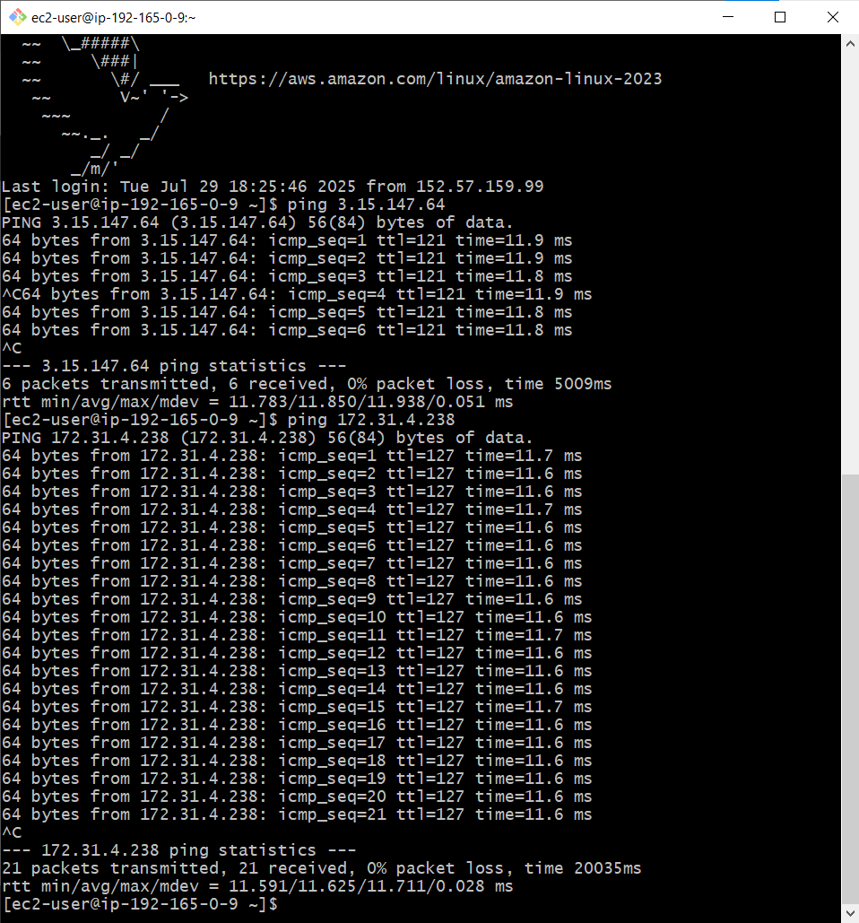

**2) Purchase one domain from godaddy.**

**For creating domain Used** [**www.namecheap.com**](http://www.namecheap.com) **taken low charge for creating domain name.**

**Domain name is taken** [**www.imrankhan.online**](http://www.imrankhan.online)

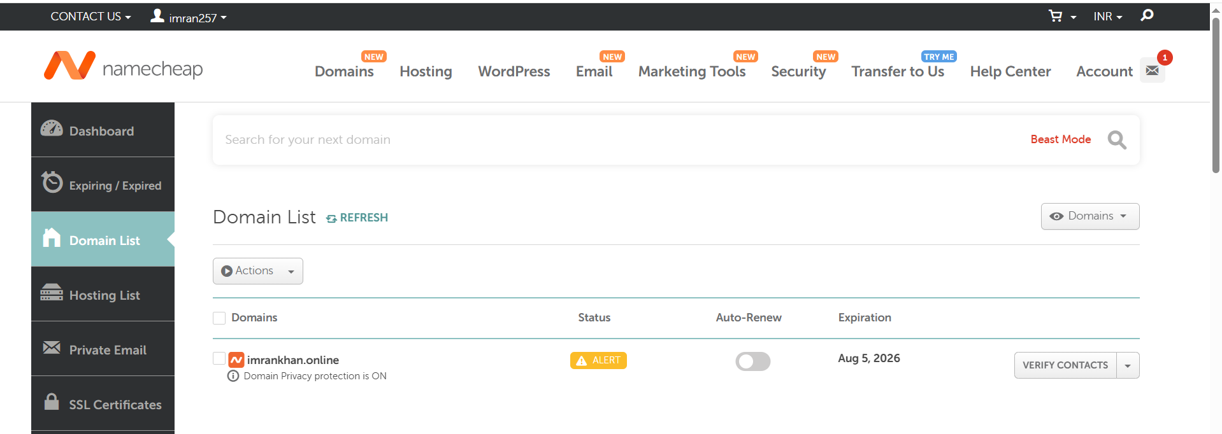

**3) Deploy static webiste in s3.**

[**http://imrankhan.online.s3-website-us-east-1.amazonaws.com**](http://imrankhan.online.s3-website-us-east-1.amazonaws.com)

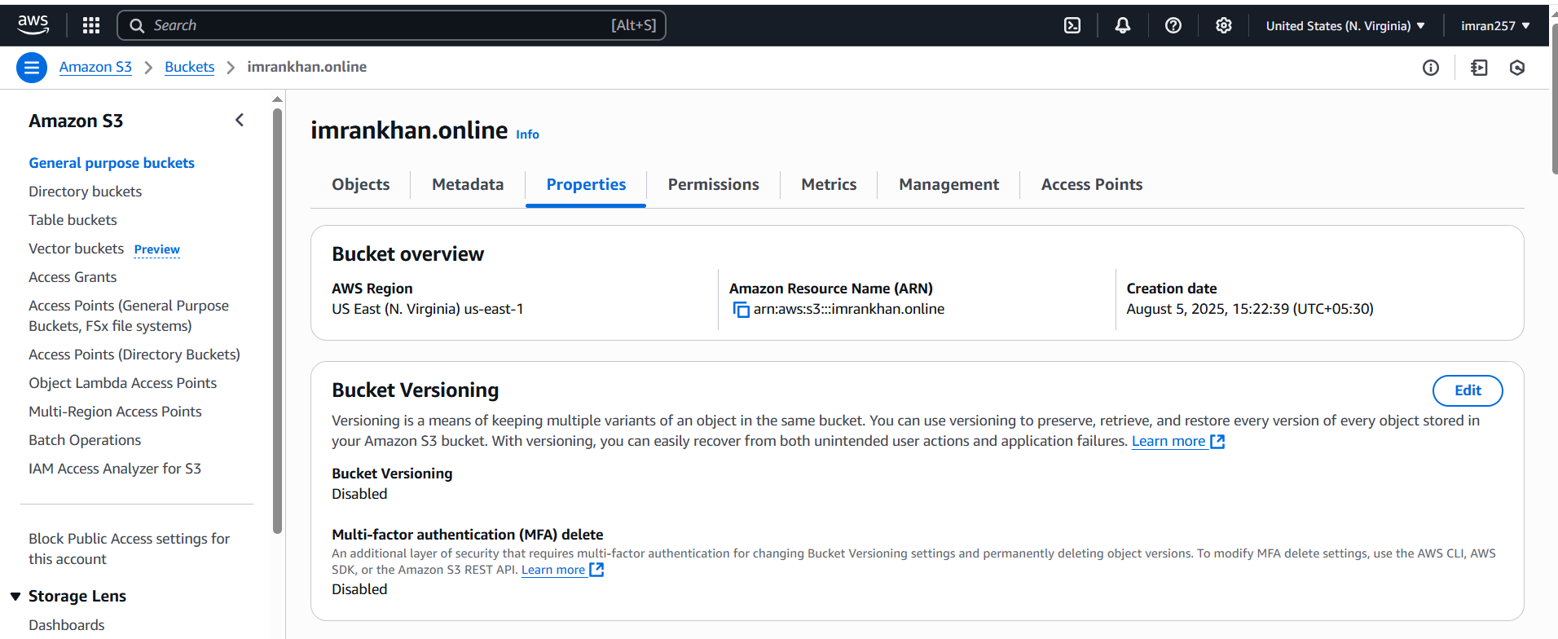

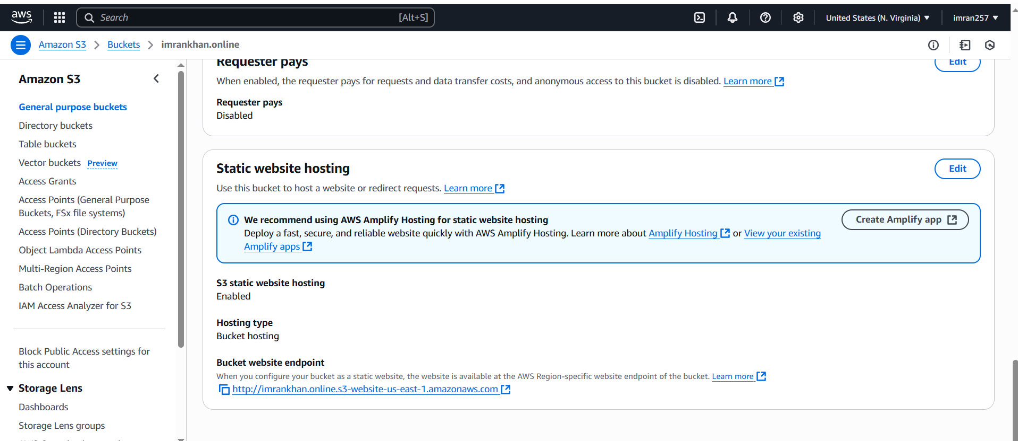

**4) Create CDN and attach one SSL certificate.**

**Amazon CloudFront is a content delivery network (CDN) service offered by Amazon Web Services (AWS).**

1. **Go to your cloud front -> distributions -> create your distribution -> select SSL certificate (or request certificate)**

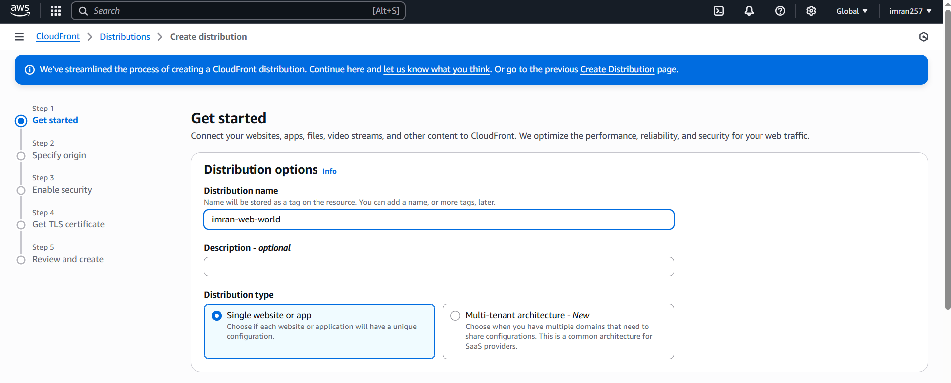

**Now take origin from S3 bucket imrankhan.online** -> properties ->**Bucket website endpoint**

**http://imrankhan.online.s3-website-us-east-1.amazonaws.com**

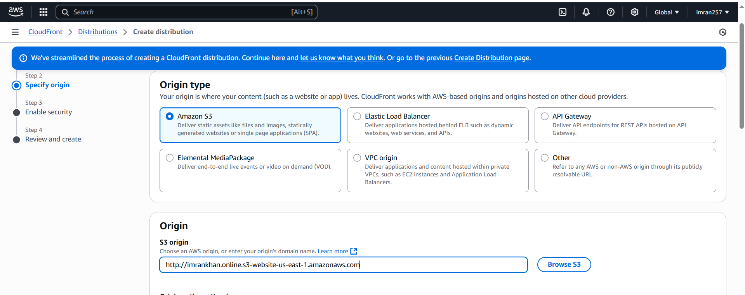

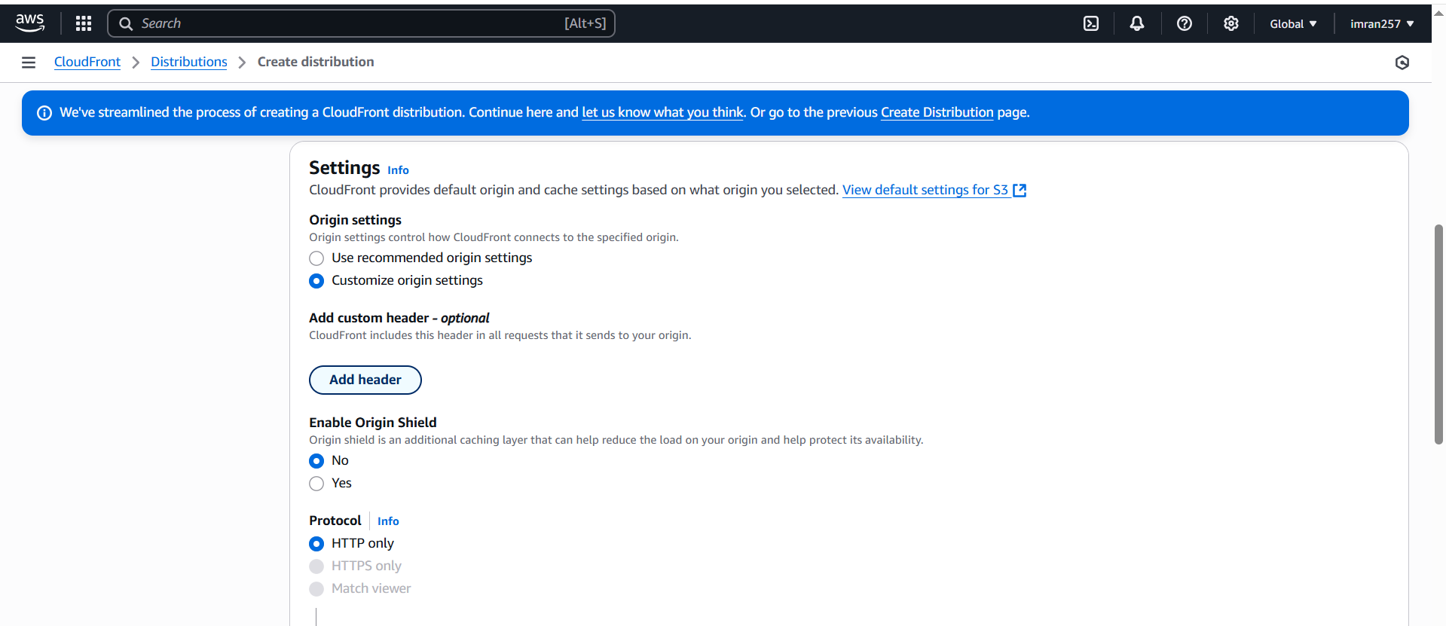

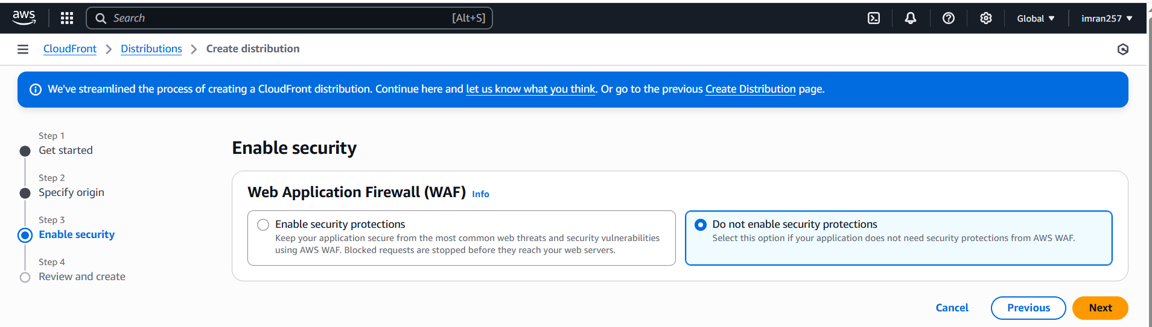

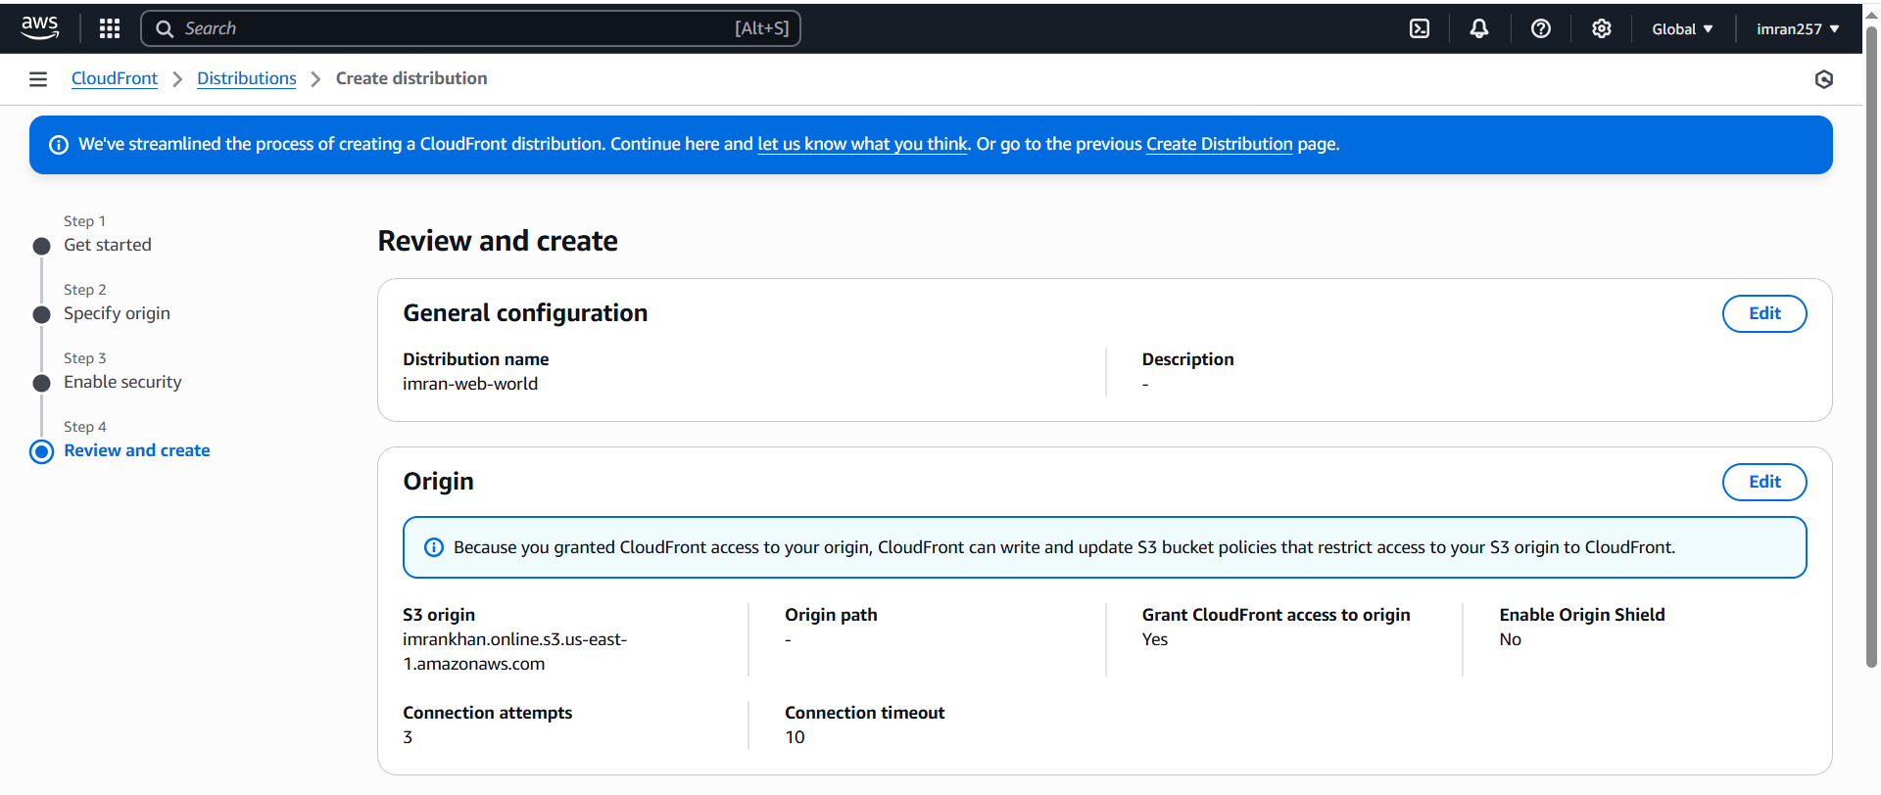

**Review and create.**

**Attach one SSL certificate.**

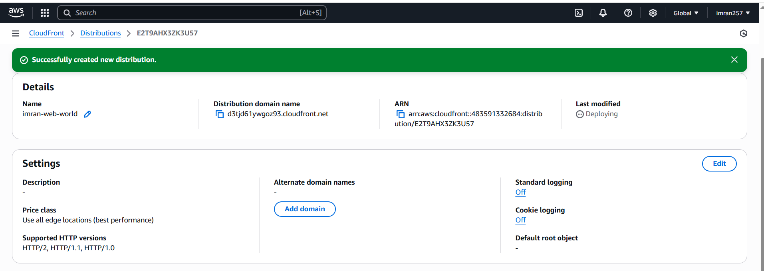

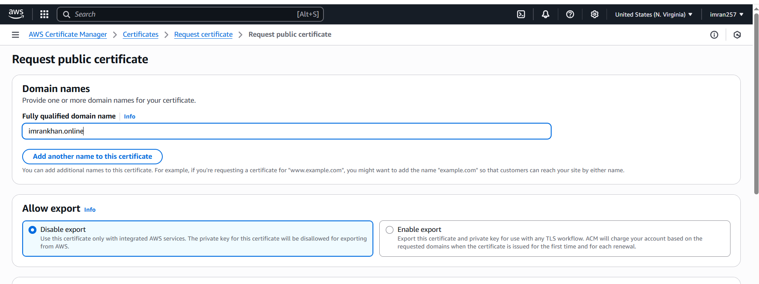

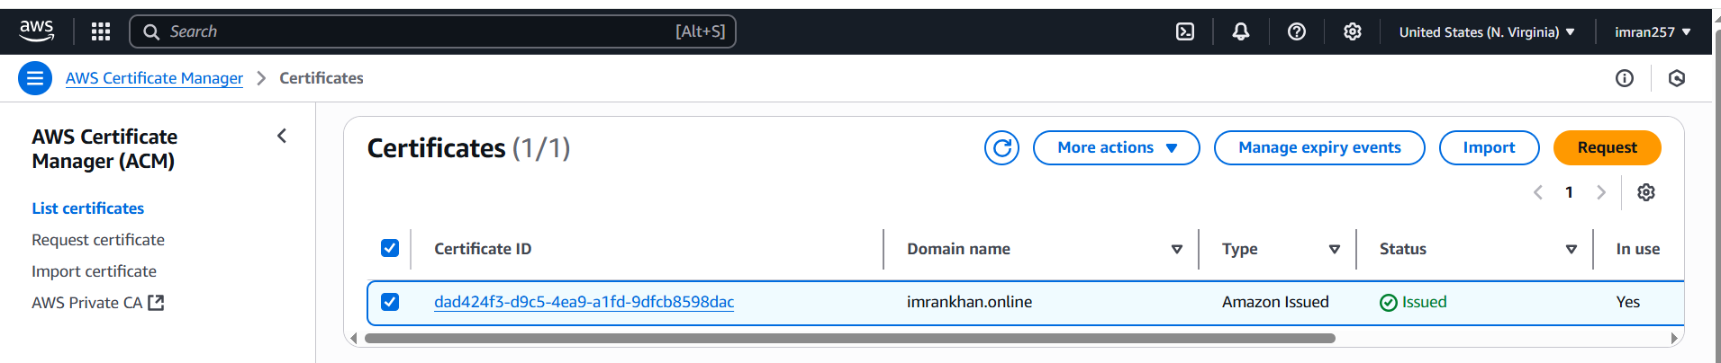

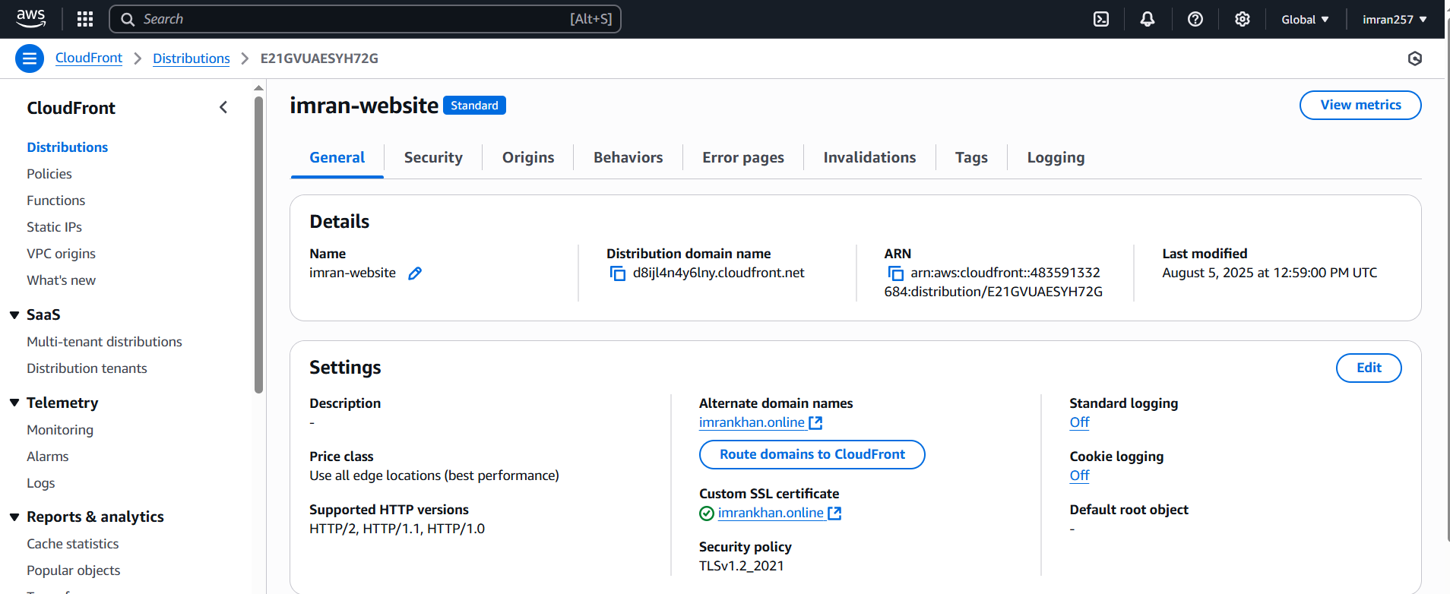

**5) Create Route53 hosted zone and MAP the domain with CDN.**

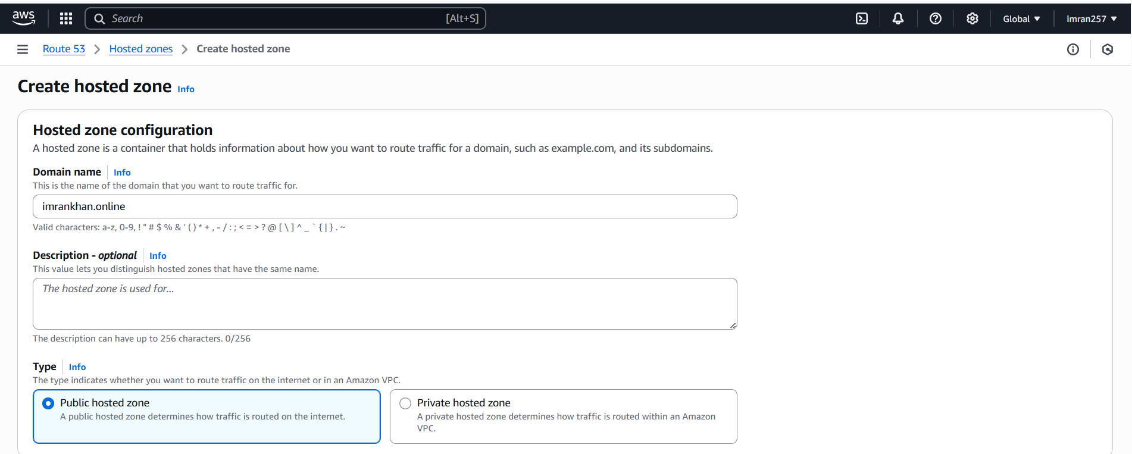

**After creating imrankhan.online hosted zone create record to map cdn as below**

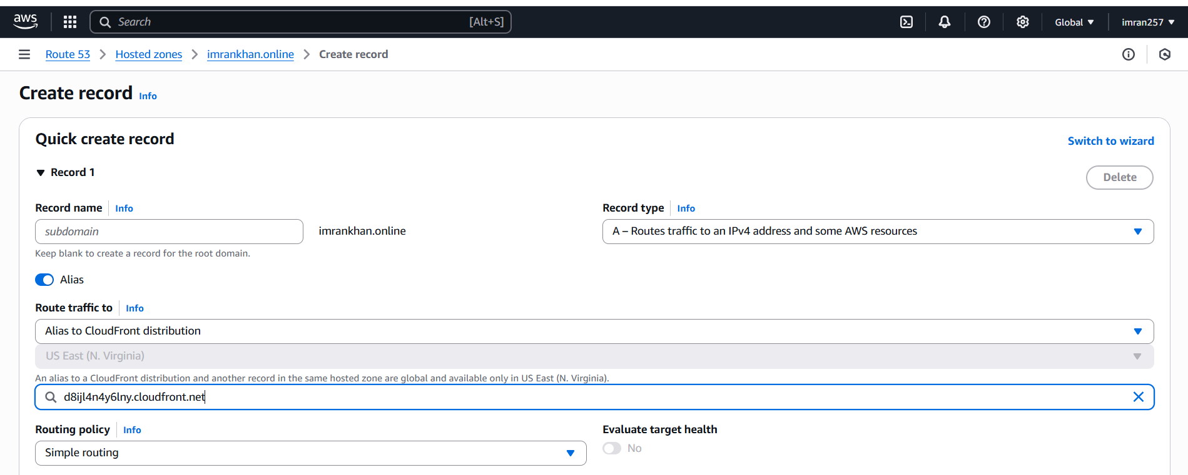

**Now you can check CNAME**

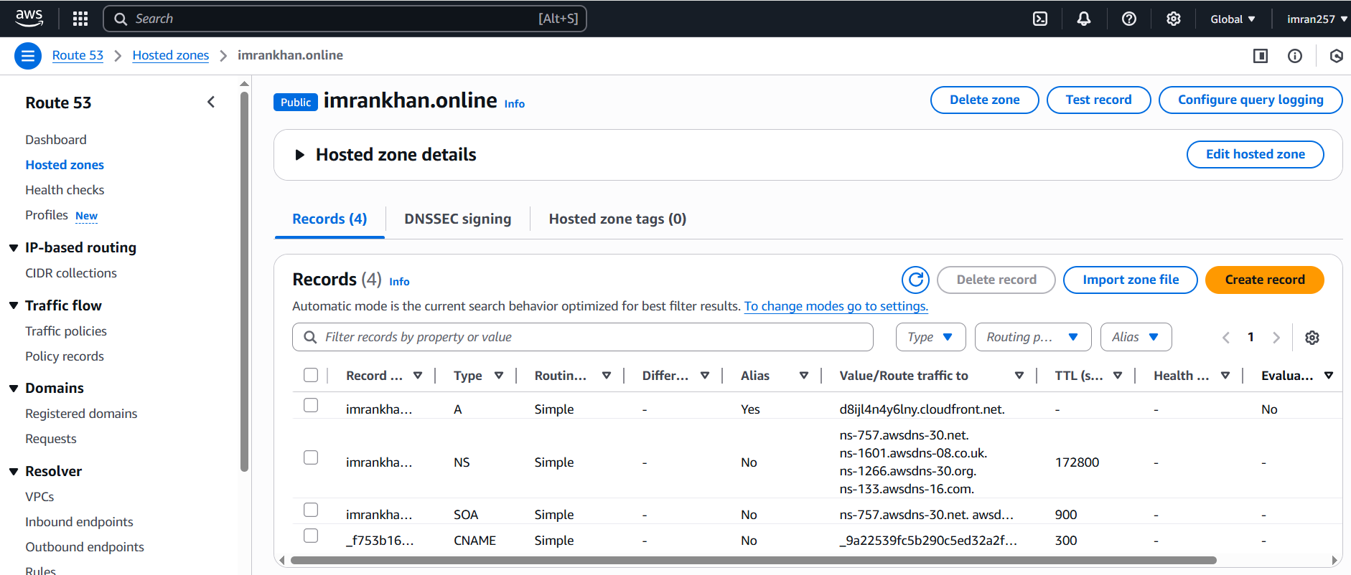

**6) Update the index.html in s3 bucket and the updated file should be accessible by using domain name.**

**https://imrankhan.online/**

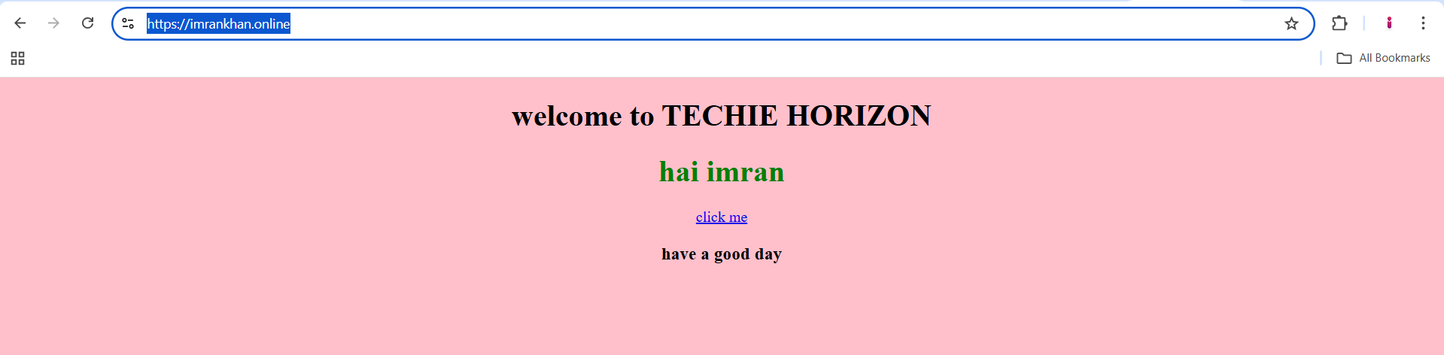

**7) Share the Domain name in slack to test the connetivity.**

[**https://imrankhan.online/**](https://imrankhan.online/)